**Assignment -3**

|  |  |
| --- | --- |
| Assignment Date | 06 oct 2022 |
| Student Name | Vijayalakshmi. R |
| Student Roll Number | 211519106178 |
| Maximum Marks | 2 Marks |

**Question-1:**

1.Create a Bucket in IBM object storage.

**Solution**

**:**

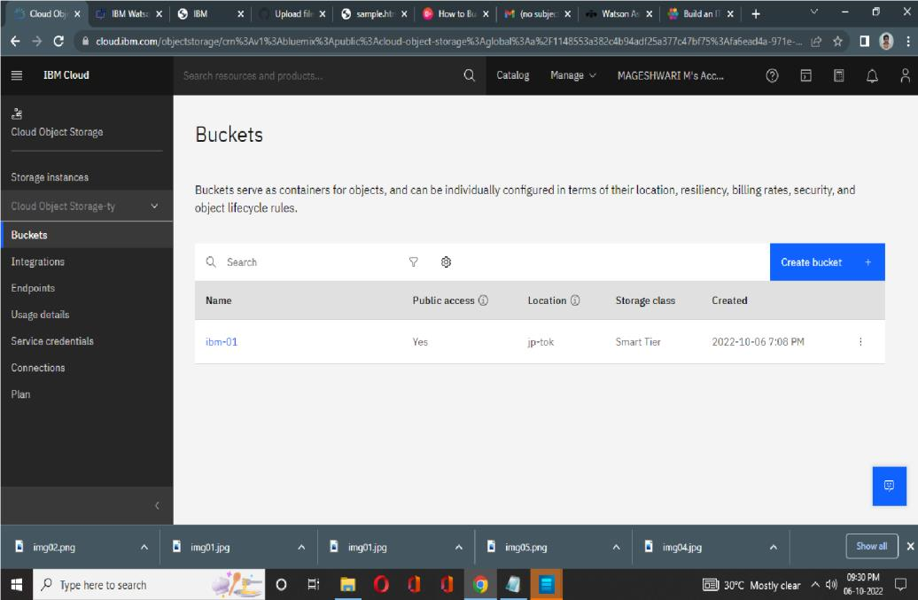

**Question-2:**

Upload an 5 images to ibm object storage and make it public. write html code to displaying all the 5 images.

**Solution:**

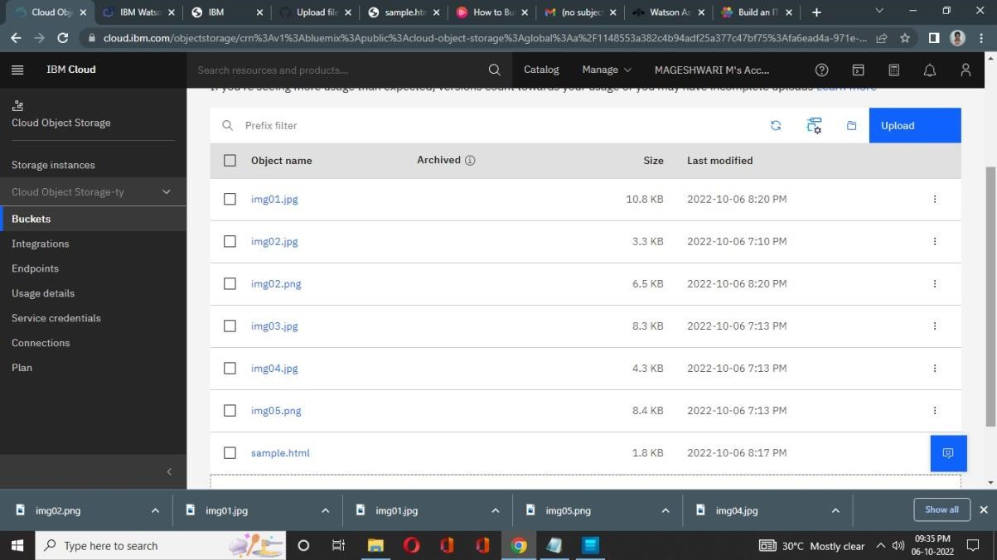

**Question-3:**

Upload a css page to the object storage and use the same page in your HTML code.

**Solution:**

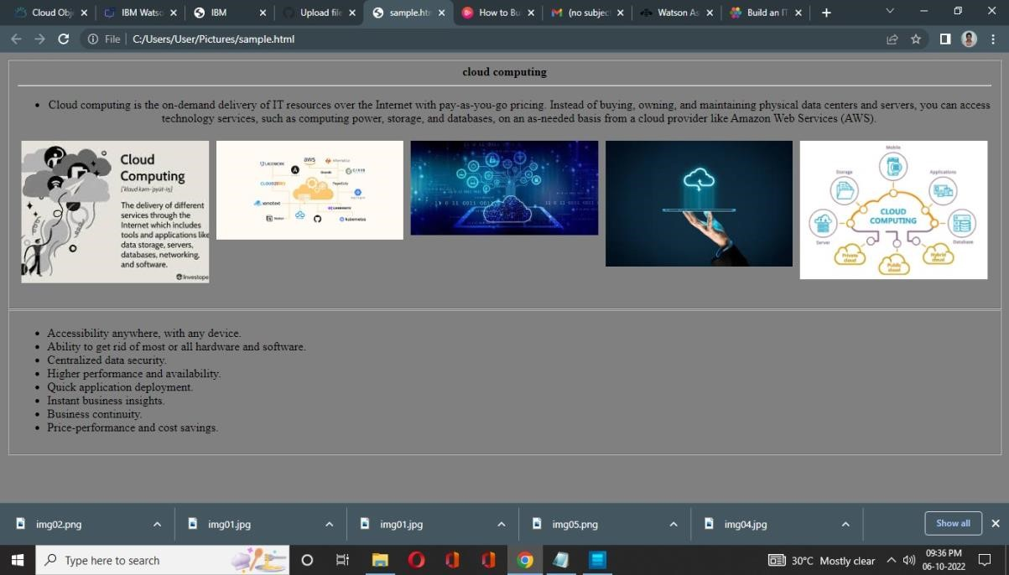

**Question-4:**

Design a chatbot using IBM Watson assistant for hospital. Ex: User comes with query to know the branches for that hospital in your city. Submit the web URL of that chat bot as a assignment.

**Solution:**

[https://web-](https://web-chat.global.assistant.watson.appdomain.cloud/preview.html?backgroundImageURL=https%3A%2F%2Fau-syd.assistant.watson.cloud.ibm.com%2Fpublic%2Fimages%2Fupx-eaf9068f-bc21-4c96-887e-24827505b9cb%3A%3Aef4f1dac-91b9-436e-b54e-e9d8e56f29db&integrationID=0154c063-eca1-4d8c-8410-78008eb28eb5&region=au-syd&serviceInstanceID=eaf9068f-bc21-4c96-887e-24827505b9cb)

[chat.global.assistant.watson.appdomain.cloud/preview.html?backgroundImageURL=https%3A%2F%](https://web-chat.global.assistant.watson.appdomain.cloud/preview.html?backgroundImageURL=https%3A%2F%2Fau-syd.assistant.watson.cloud.ibm.com%2Fpublic%2Fimages%2Fupx-eaf9068f-bc21-4c96-887e-24827505b9cb%3A%3Aef4f1dac-91b9-436e-b54e-e9d8e56f29db&integrationID=0154c063-eca1-4d8c-8410-78008eb28eb5&region=au-syd&serviceInstanceID=eaf9068f-bc21-4c96-887e-24827505b9cb)

[2Fau-syd.assistant.watson.cloud.ibm.com%2Fpublic%2Fimages%2Fupx-eaf9068f-bc21-4c96887e24827505b9cb%3A%3Aef4f1dac-91b9-436e-b54e-e9d8e56f29db&integrationID=0154c063eca1-](https://web-chat.global.assistant.watson.appdomain.cloud/preview.html?backgroundImageURL=https%3A%2F%2Fau-syd.assistant.watson.cloud.ibm.com%2Fpublic%2Fimages%2Fupx-eaf9068f-bc21-4c96-887e-24827505b9cb%3A%3Aef4f1dac-91b9-436e-b54e-e9d8e56f29db&integrationID=0154c063-eca1-4d8c-8410-78008eb28eb5&region=au-syd&serviceInstanceID=eaf9068f-bc21-4c96-887e-24827505b9cb)

[4d8c-8410-78008eb28eb5&region=au-syd&serviceInstanceID=eaf9068f-bc21-4c96887e24827505b9cb](https://web-chat.global.assistant.watson.appdomain.cloud/preview.html?backgroundImageURL=https%3A%2F%2Fau-syd.assistant.watson.cloud.ibm.com%2Fpublic%2Fimages%2Fupx-eaf9068f-bc21-4c96-887e-24827505b9cb%3A%3Aef4f1dac-91b9-436e-b54e-e9d8e56f29db&integrationID=0154c063-eca1-4d8c-8410-78008eb28eb5&region=au-syd&serviceInstanceID=eaf9068f-bc21-4c96-887e-24827505b9cb)

**Question-5:**

Create Watson assistant service with 10 steps and use 3 conditions in it. Load that script in HTML page.

**Solution:**

